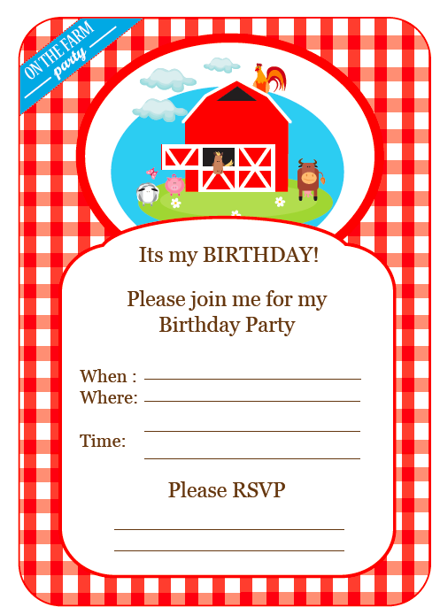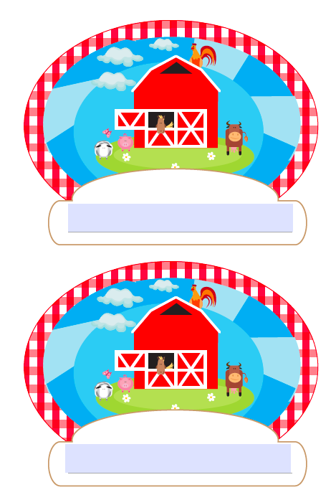

menu

**Farmer’s Market Platter**

An assortment of Fruit and Veggies

**Pigs in Blankets**

Grilled Sausages and Bread Rolls

**Chicken Littles**

Chicken Nuggets

**Hay Piles**

Piles of French Fries

**Corn on the Cob, Cole Slaw**

**and Corn Bread**

Cow Pies and Moo Cream

Chocolate Brownies and Ice Cream

shovels

pitches